Name: Arpit Mahalle
Day 16 screenshots of output
Challenge 1
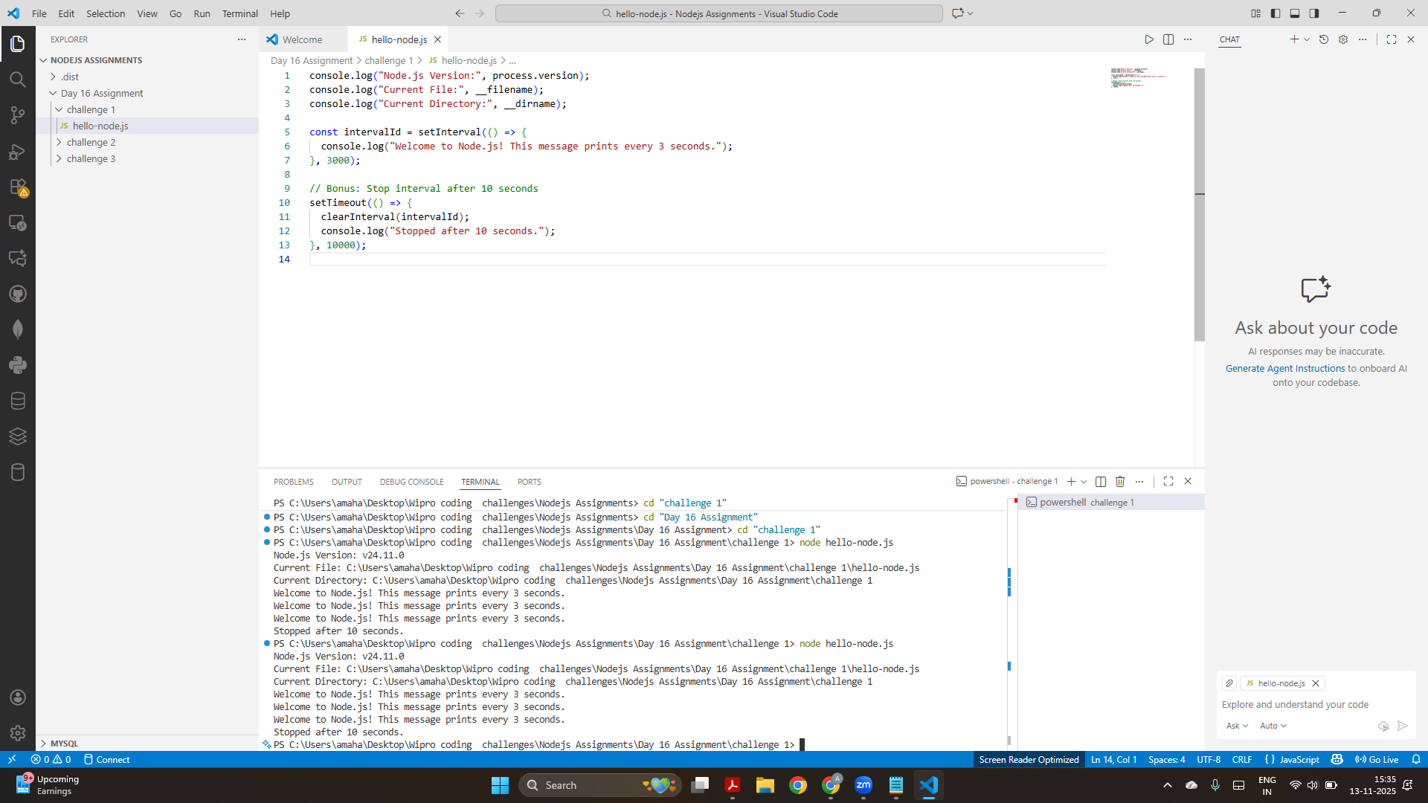
This is the output of challenge 1 where the output is displayed in the terminal every 3 seconds and after the completion of 10 seconds the program terminates automatically.

Challenge 2:
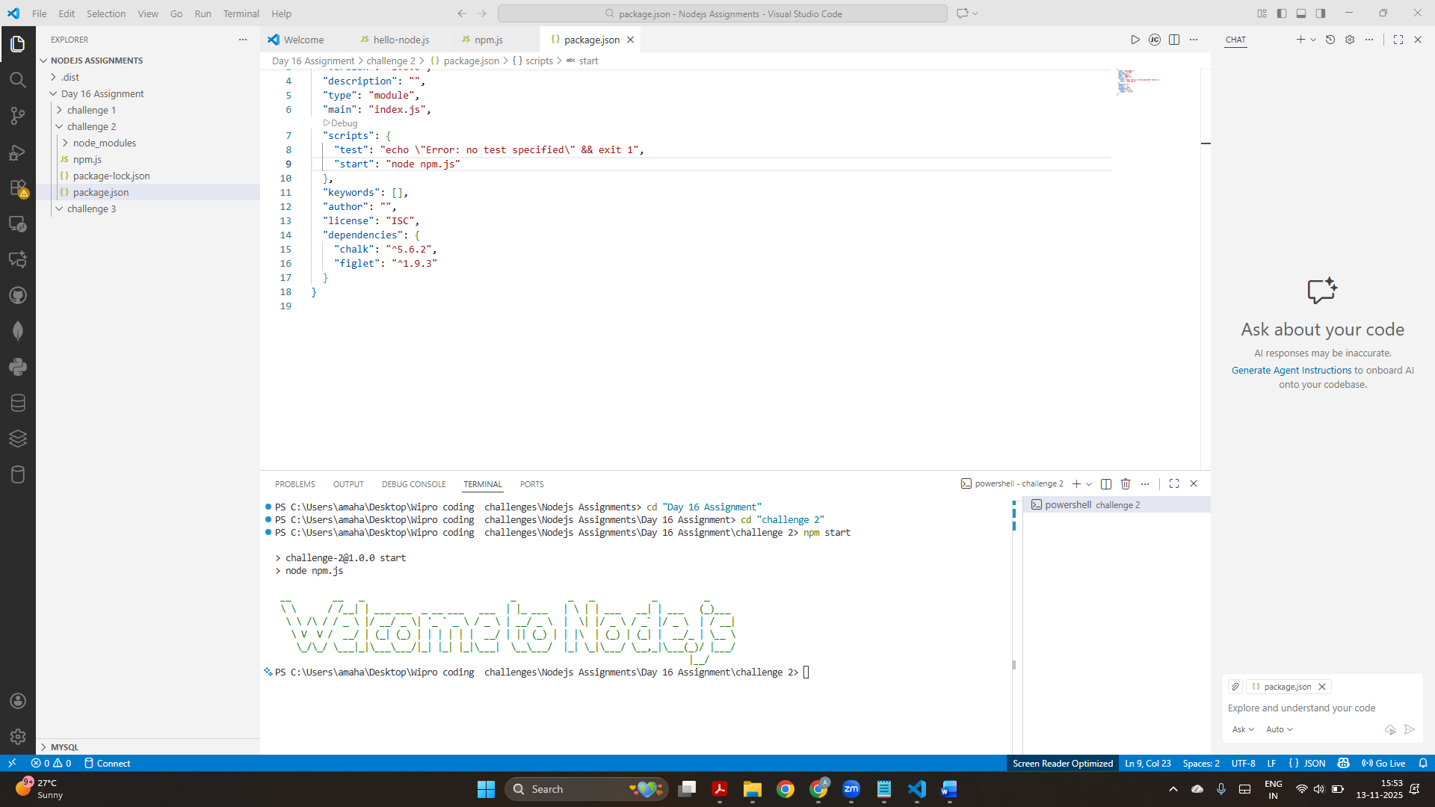
This is the output of challenge 2 where the output is displayed in colourful “Welcome to Node.js” banner using figlet and chalk. I also added a start script in package.json so that this program can be executed with “npm start”.

Challenge 3
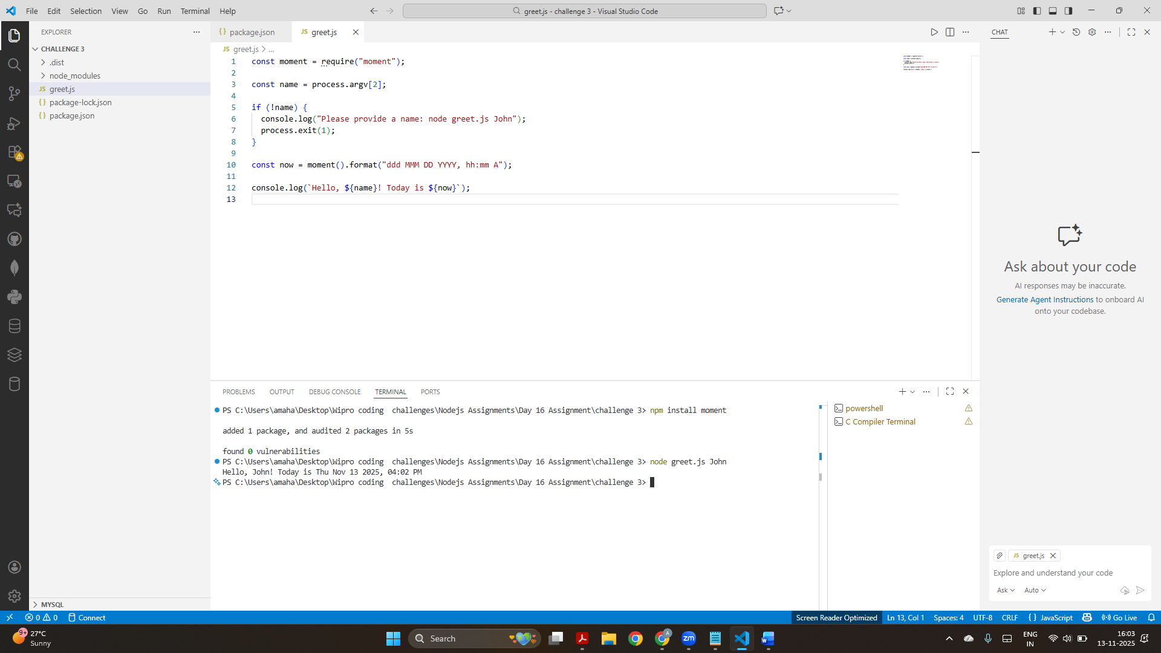
This screenshot displays the output from greet.js file which prints the correctly formatted date-time greeting when run with name argument.

